NETWORKING 3

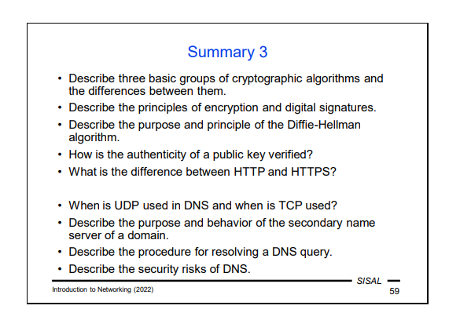
3 basic groups of cryptographic algorithms and the differences between them:
Symmetric cryptography/encryption, Asymmetric cryptography/encryption, Hash function
Symmetric encryption is based on the fact that the receiver gets the same information that we use for encoding so that he/she can decode the data, very fast. Disadvantage: the size of the problem is reduced, the big message can be sent safely, but the key still needs to be transmitted securely.
Asymmetric encryption on the other hand is slow, suitable for only small data, but is more secure if we carefully verify the public key, we need a public one and a private key, mutually nondeductible. Uses 2 different keys, one for encryption and one for decryption.
Hash function is a function that creates a code of short fixed length from any data. They are designed to be one-way functions, meaning you cannot derive the original data from the hash. Useful for integrity checks, for weak functions it is possible to produce collisions.

Principles of encryption and digital signatures.
The encryption principles are encrypting and decrypting messages by using keys, symmetric using the same key, and asymmetric using pairs of private and public keys, while digital signatures use encryption and hash function to check data integrity. A text is sent with the encrypted hashed text. That text is hashed by the receiver and the encrypted hashed text is decrypted. After that, the 2 texts are compared to check if data has been changed.
Purpose and principle.
Diffie-Hellman algorithm is a method used for information exchange between 2 partners through an open channel. The idea is that both sides each keep a secret for communication and use one-way functions to calculate the shared secret, which would be hard to deduct without knowing both of the secret parts. The key principle behind the algorithm is based on one-way functions, which means it is computationally easy to perform certain operations in one direction but difficult to reverse them.

Authenticity of a public key verification
One way is to attach an identity tag to the key and let someone confirm that the coupling is correct.
PGP keys for e-mail signing use the method of a web of trust, but Public Key Infrastructure uses Certification Authorities for signing key+tag pairs

What is the difference between HTTP and HTTPS?
HTTPS means HTTP over SSL. This means that it is an HTTP protocol with Secure Socket Layer interlayer added between the application and transport layers.

When UDP used in DNS and when is TCP?
Common requests(up to 512B) use UDP and larger data transfers use TCP.
------
UDP allows the client to respond more quickly to any slow or missing server responses. Originally, the limit for a UDP message was 512 bytes, but today the extended protocol (EDNS) is commonly used, which allows the client and server to agree on larger sizes.
• If a response exceeds the size limit, the server sends only the part that fits in the message and sets the TC (truncated) flag. The client can then repeat the query using TCP to obtain a complete answer. Some data exchanges (e.g. database updates between servers) take place directly in TCP.
A common client implementation is to sequentially query the servers it has in its configuration (think about why it has addresses of servers there, not their names), gradually increasing its timeout for receiving a response (usually starting at 0.5 sec) until a response is received. If the response does not contain the necessary information, it should include a link to other servers that should be queried to get it.

Purpose and behavior of a secondary name server of a domain.
secondary (or "slave") servers are usually set up as backups. They periodically download the current contents of the database from the primary server.
Procedure for solving a DNS query.
A DNS query consists of a header that contains, among other things, a 2-byte random number (identifier) of the query and flags (e.g. a recursive response request), and a so-called QUERY section with a single RR containing the queried name and type (this record is exceptional in that it does not have a data part).
The answer again contains the query identifier and flags (e.g. the authority of the answer) in the header and the repeated query in the QUERY section. This is followed by an ANSWER section containing RRs with answers, an AUTHORITY section containing a list of name servers that can give an authoritative answer or at least authoritative information about some of the parent domains contained in the query, and an ADDITIONAL section containing additional information (addresses of name servers from the AUTHORITY section, addresses of the MX servers listed in the ANSWER section, etc.).

Security risks of DNS.
cache poisoning attack. An attacker legally operates a server for a domain and forces the client to send him a DNS query (for example, by a spamming advertisement). The query contains a correct answer (making the attack more insidious), but the AUTHORITY section contains faked information that e.g. the server for the cz domain is also this attacker's server. And if the client is naive, it caches this false information and from then on the attacker gains complete control over queries directed to the cz domain from the given client (or worse –from the whole network).
The risk is that the attacker might gain complete control over queries directed to the cz domain from the given client (or worse –from the whole network).

